Coal lab no 5

24k-0821 Jeevan Kumar

Qno 1

Code : include irvine32.inc

.data

.code

main proc

mov eax,15000

call dumpregs

add eax , 1

call dumpregs

exit

main endp

end main

Output:

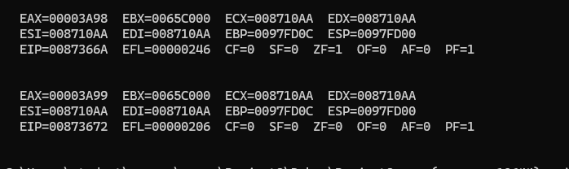

Qno 2

Code: include irvine32.inc

.data

.code

main proc

mov ax , 0A2FFh

call dumpregs

add al , 15h

call dumpregs

add ah , 1h

call dumpregs

add ax , 2h

call dumpregs

exit

main endp

end main  
Output: 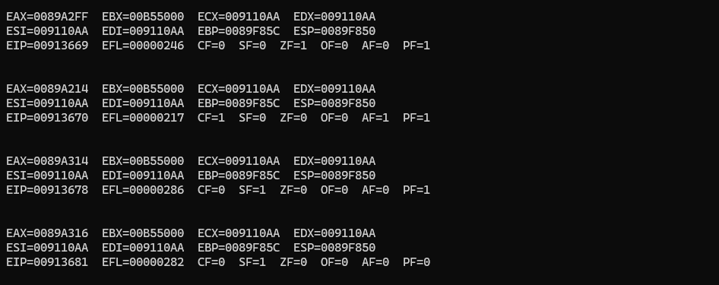

Qno 3

Code:

include irvine32.inc

.data

array word 65,22,33,23,55

array2 word 22,23,33,55,65

.code

main proc

mov ax , [array2]

movzx eax ,ax

call dumpregs

call crlf

mov ax , [array2+2]

movzx eax ,ax

call dumpregs

call crlf

mov ax , [array2+4]

movzx eax ,ax

call dumpregs

call crlf

mov ax , [array2+6]

movzx eax ,ax

call dumpregs

call crlf

exit

main endp

end main

Output:

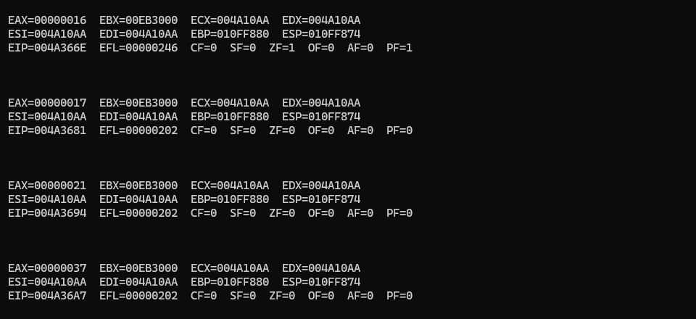

Qno 4

Code: INCLUDE Irvine32.inc

.data

arrayb byte 25,45,65

arrayw word 155,185,225

arrayd dword 645,690,735

sum1 dword ?

sum2 dword ?

sum3 dword ?

.code

main proc

movzx eax, arrayb[0]

movzx ebx, arrayw[0]

add eax,ebx

add eax,arrayd[0]

mov sum1,eax

movzx eax, arrayb[1]

movzx ebx, arrayw[2]

add eax,ebx

add eax,arrayd[4]

mov sum2,eax

movzx eax, arrayb[2]

movzx ebx, arrayw[4]

add eax,ebx

add eax,arrayd[8]

mov sum3,eax

mov eax , sum1

call writedec

call crlf

mov eax ,sum2

call writedec

call crlf

mov eax , sum3

call writedec

call crlf

exit

main endp

end main

